**Activity 4:** Temperature Convertor and Challenge

Ryan Scott

Grand Canyon University  
Mobile Game Development

Prof. Shad Sluiter

**Temperature Converter Screenshots:**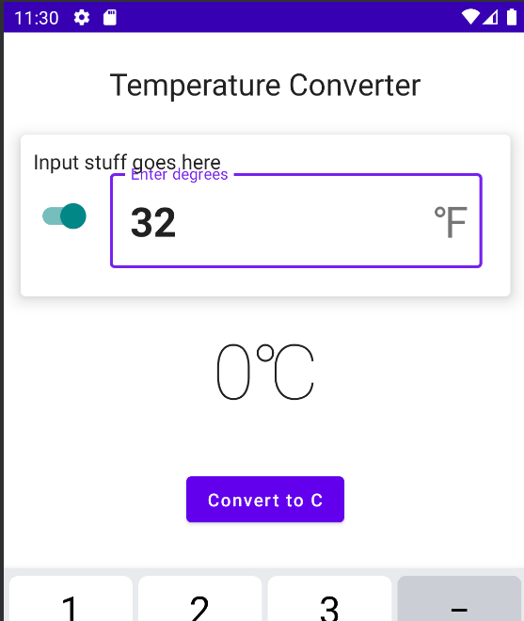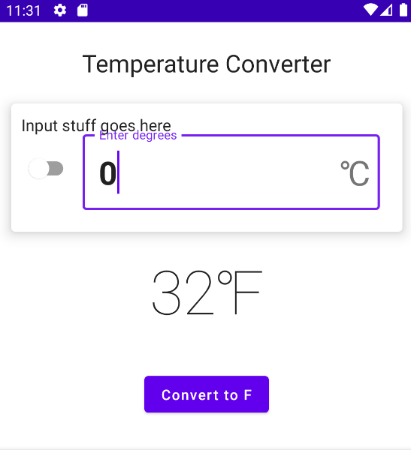

**Timezone Translator Challenge Screeshot:**

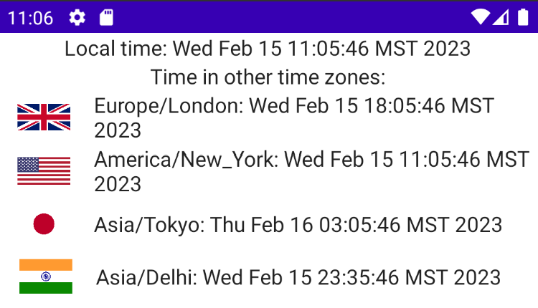

# What I learned

I used Jetpack Compose to create the UI. Some of the UI elements I used include Text, Column, Row, Button, OutlinedTextField, Switch, Card, and Surface.

Each of these UI elements has various properties and modifiers that can be applied to change its appearance, layout, and behavior. Jetpack Compose also allows us to create our own custom UI elements and modifiers, giving us a high degree of flexibility and control over the appearance and functionality of our applications.

I also experimented with learning more about working with resources in Android development. Specifically, I learned how to add image resources to my project's drawable directory, how to reference those resources in my code, and how to manipulate them in various ways (such as setting their dimensions or displaying them in a Card view).